**Delivery Hiring**

The Delivery Hiring study case comprises two companies, STORE (which has an online sales system) and Fast Delivery (a company specializing in parcel delivery). STORE sells online; however, it does not have its own delivery service. To meet the demand for deliveries, STORE hires the services of the company FAST Delivery. The Fast Delivery company has an online ordering system in which customers can forward delivery requests.

In order to automate the delivery request, the STORE uses an integration process which allows identifying new sales made in the online store system and forwards the delivery request to the Fast Delivery system.

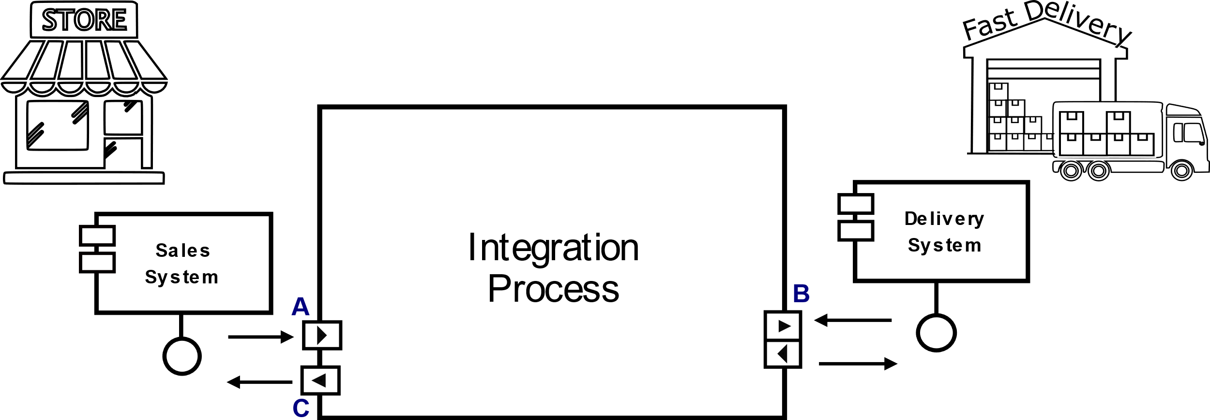

The Fast Delivery company has some service plans that other companies can hire. For example, the delivery plan contracted by STORE consists of 200 monthly deliveries, with a limit of 10 daily deliveries.

The terms and conditions regarding the provision of contracted services are described below:

**Rights and Obligations of the STORE**

**Rights**

The STORE has the right to send orders to the Fast Delivery company from Monday to Friday, between 8:30 am and 6:30 pm.

The STORE has the right to send up to 10 delivery orders per day to the Fast Delivery company and up to 200 delivery orders per month.

**Obligations**

A delivery request to the Fast Delivery company must contain the origin address, where the package/product will be picked up, and a destination address, where the delivery must delivery.

**Obligations of the Fast Delivery Company**

**Obligations**

The Fast Delivery company must respond to requests within a maximum of 15 minutes.

The Delivery System must provide a budget containing the cost of the service that will be provided.

**Representar os termos e condições em um contrato utilizando o Jabuti DSL**

The request for deliveries is carried out automatically through an integration process. In this context, communication occurs independently between the integration process and each application (Sales System and Delivery System). The communication between the integration process and the applications occurs through the communication ports. Considering the Delivery Hiring case study, the communication between the integration process and the Sales System application occurs through ports **A** and **C**, and the communication with the Delivery System application occurs through port **B**.

Considering that the integration process belongs to STORE and the aim is to monitor the delivery requests made to the Delivery System application, it is possible to define a smart contract using the Jabuti DSL. Through this smart contract, it is possible to express the terms and conditions defined for the delivery service providers and monitor the communication between the integration process and the Delivery System application through port **B**.

The following describes the terms and conditions regarding the provision of service by the company Fast Delivery, considering the communication rules between the integration process and the Delivery System.

**Integration Process**

**Rights of the Integration Process**

The integration process has the right to send orders to the Delivery System from Monday to Friday, between 8:30 am and 6:30 pm.

The integration process has the right to send up to 10 delivery orders per day to the Delivery System and cannot exceed 200 delivery orders per month.

**Obligations of the Integration Process**

A delivery order sent to the Delivery System must contain only an origin address, where the package/product will be picked up, and a destination address, where the delivery must take place.

**Delivery System**

**Obligations of the Delivery System**

The Delivery System must respond to requests within a maximum of 15 minutes.

The Delivery System must provide a budget containing the cost of the service that will be provided.